Assignment 1 – Computer Vision

Prepared by
Dylan Gartin

Course name -Computer Vision (SP 2022)
Course number - CAP4410.01
Date of submission – 2/4/2022
Table of Contents
Table of Contents 1
List of Figures 2
List of Tables 3
List of Acronyms 4
1. OpenCV First Project 5
1.1 Assignment Introdghjyghjygfhgfhuction 5
1.2 Process and Development. 5
1.3 Results and Conclusion 12
1.4 UPDATE: Extension and New Information 15
1.5 References 17
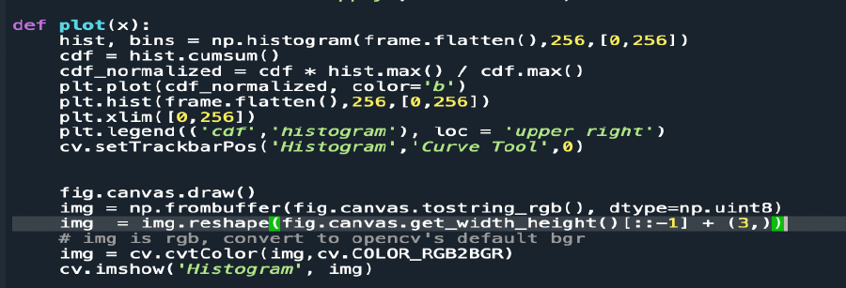 18
2. Failed code models 18

OpenCV First Project

Assignment Introdghjyghjygfhgfhuction
This assignment is to make a brightness and contrast adjustment to a video while also displaying a histogram for the video on it. In order to do this, you need to output two videos, one for a reference and the other to apply changes to. I am Dylan Gartin and, in this report, we’ll be going over the basic steps that were used in order to create this.

The conditions we need to meet are the following:
- Format of report 05 points
- Brightness increase decrease functionality 20 points
- Contrast increase decrease functionality 20 points
- Continuous video 10 points
- Live histogram for original and edited video 15 points
- Implementation of brightness and contrast by sliding bar 20 points
- Save the edited video 10 points

And without further ado let’s get into the development process.

Process and Development.
The following steps were how this code reached its final stage of development.

Step 1: Research the issue and find various solutions
The first step that we partake in was researching the issue in it of itself, overall, we found a
Lot of the information online, however unfortunately all of what we were able to find was mostly outdated. Had its own errors inside of they’re processes and required more knowledge about python then that I currently have. Here are some of the sources we have used for codes. The full list of this would be over 100 different sites at this point (not an exaggeration), which we think would be absurd to go over for this assignment. As such we will only mention the main codes used to try to produce an output.

Image Contrast and Brightness Slider – Geeks for Geeks –

This is a brightness and contrast slider that allows you to adjust the image brightness and contrast of an image file. Honestly would be very useful, if we didn’t need this for video files, and also if it worked consistently, as sometimes it will have completely random errors, thus making it rather unreelable. As such we can’t really decipher much from this code.

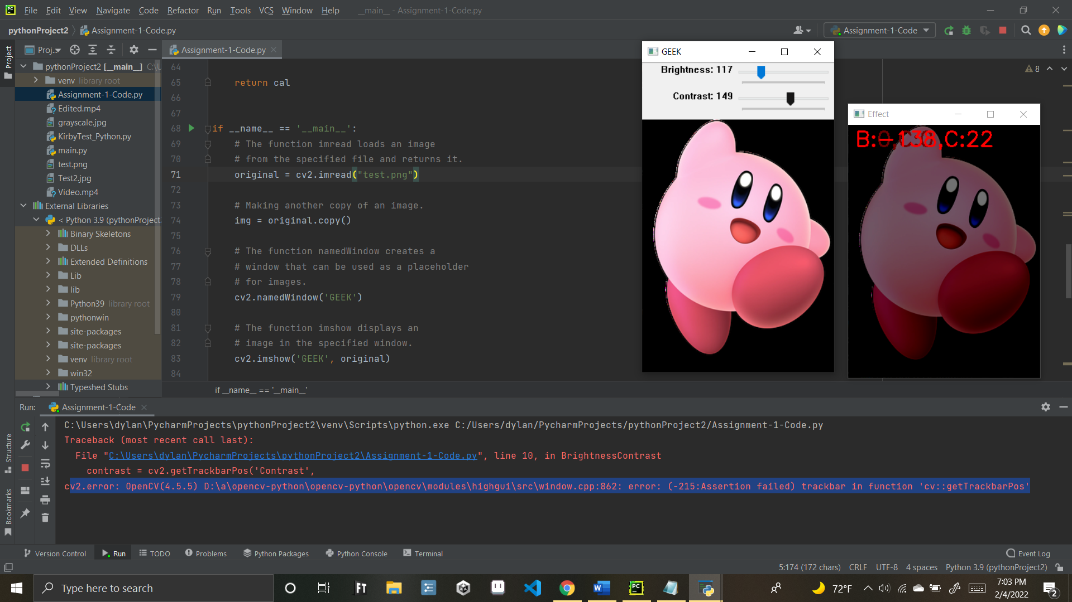

import cv2

def BrightnessContrast(brightness=0):

# getTrackbarPos returns the current
# position of the specified trackbar.
brightness = cv2.getTrackbarPos('Brightness',
'GEEK')

contrast = cv2.getTrackbarPos('Contrast',
'GEEK')

effect = controller(img, brightness,
contrast)

# The function imshow displays an image
# in the specified window
cv2.imshow('Effect', effect)

def controller(img, brightness=255,
contrast=127):

brightness = int((brightness - 0) * (255 - (-255)) / (510 - 0) + (-255))

contrast = int((contrast - 0) * (127 - (-127)) / (254 - 0) + (-127))

if brightness != 0:

if brightness > 0:

shadow = brightness

max = 255

else:

shadow = 0
max = 255 + brightness

al_pha = (max - shadow) / 255
ga_mma = shadow

# The function addWeighted calculates
# the weighted sum of two arrays
cal = cv2.addWeighted(img, al_pha,
img, 0, ga_mma)

else:
cal = img

if contrast != 0:
Alpha = float(131 * (contrast + 127)) / (127 * (131 - contrast))
Gamma = 127 * (1 - Alpha)

# The function addWeighted calculates
# the weighted sum of two arrays
cal = cv2.addWeighted(cal, Alpha,
cal, 0, Gamma)

# putText renders the specified text string in the image.
cv2.putText(cal, 'B:{},C:{}'.format(brightness,
contrast), (10, 30),
cv2.FONT_HERSHEY_SIMPLEX, 1, (0, 0, 255), 2)

return cal

if __name__ == '__main__':
# The function imread loads an image
# from the specified file and returns it.
original = cv2.imread("pic.jpeg")

# Making another copy of an image.
img = original.copy()

# The function namedWindow creates a
# window that can be used as a placeholder
# for images.
cv2.namedWindow('GEEK')

# The function imshow displays an
# image in the specified window.
cv2.imshow('GEEK', original)

# createTrackbar(trackbarName,
# windowName, value, count, onChange)
# Brightness range -255 to 255
cv2.createTrackbar('Brightness',
'GEEK', 255, 2 * 255,
BrightnessContrast)

# Contrast range -127 to 127
cv2.createTrackbar('Contrast', 'GEEK',
127, 2 * 127,
BrightnessContrast)

BrightnessContrast(0)

# The function waitKey waits for
# a key event infinitely or for delay
# milliseconds, when it is positive.
cv2.waitKey(0)

Figure 1 - Geek for Gkuyfvghfd ydrfdvjtyvdfhjytdjytdytjvdytvjdjytveeks image contrast Slider / code

Code for rendering images with histograms -OpenCV official site

When it came time to make a histogram, we really only needed the following snipit of code, which was provided by open cv officially.

import numpy as np
import cv2 as cv
from matplotlib import pyplot as plt
img = cv.imread('home.jpg',0)
plt.hist(img.ravel(),256,[0,256]); plt.show()

Figure 2 – Open CV histograms

However, there is the issue with this not updating automatically, there were a few videos explored and looked into. However, the actual code themselves ran with errors that did not produce a desired output, as such this is as close as we were able to get based on our knowledge of open CV

Code that is used for rendering video - LearnOpenCV

Another code that was a big help was this bit from learn OpenCV, this bassically explains how to play two videos side by side together, and in combination with a bit of for looping you can even make these play on loop continuously this allows both videos to be played side by side and is pretty useful for such. Unfortunately, however it is not directly compatible with the picture code.
# import the cv2 library
# import the cv2 library - Displays two videos, still needs histograms proprer saving and adjustment bars implemented correctly
import cv2
# Import this for the histogram
import numpy as np
from matplotlib import pyplot as plt
# Create a VideoCapture object and read from input file
# If the input is the camera, pass 0 instead of the video file name
#cap is the starting default video, Cappy is the edited copy of the vide
cap = cv2.VideoCapture('Video.mp4')
cap1 = cv2.VideoCapture('Video.mp4')
# Check if camera opened successfully
if (cap.isOpened() == False):
print("Error opening video stream or file: Default video ")
if (cap1.isOpened() == False):
print("Error opening video stream or file: Editing Video did not display")
# Read until video is completed
while (cap.isOpened()):
# Capture frame-by-frame
ret, frame = cap.read()
ret1, frame2 = cap1.read()
if ret == True:
# Display the resulting frame of the video
cv2.imshow('Base Video', frame)
cv2.imshow('Video Adjustment', frame2) #Note Framer is
# loop the video once it reaches the end
if ret == False:
cap = cv2.VideoCapture('Video.mp4')
cap1 = cv2.VideoCapture('Video.mp4')
ret, image = cap.read()
ret1, image2 = cap1.read()
# Press Q on keyboard to exit the video program
if cv2.waitKey(25) & 0xFF == ord('q'):
break
if cv2.waitKey(25) & 0xFF == ord('s'):
#save the changes to the video and then exit
break
cap.release()
cap1.release()
cv2.destroyAllWindows()

Figure 3 – Open CV video rendering code with adjustment to do double video

Step 2: Find various solutions have own main issues
While the solutions worked in a vacuum for the most part whenever trying to combine these solutions one

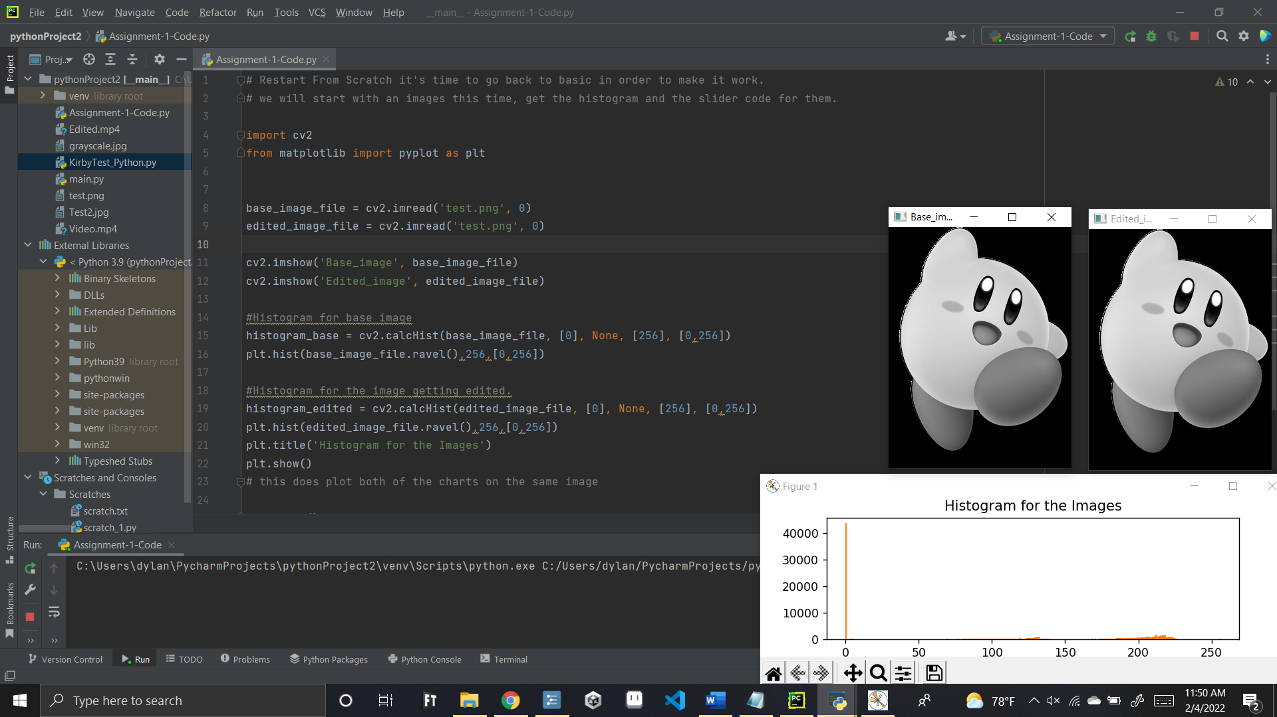
For one the save feature only saves the original one without the modified data, until it doesn’t. if you set it to save the new image, it will save it with the output information, but it also fails to actually apply the adjustments to the brightness or contrast. It also for some reason does not want to work for key presses. From what I can tell it is part due to the histogram also being rendered.

Figure 4 – Open CV histogram rendering issue

Other issues occurred when trying to update histograms, mainly due to the fact that they render on the same histogram chart despite trying to divide the two. This means that despite there being two sets of data it cannot be told when they are same values.

Lastly the other main issue with this would be the fact that a lot of the code is not interchangeable, what works for an image does not work for a video and vice versa. As such we simply are in the dark about how to actually make any of this code work together and can only really hack and slash items together and test to see if the outputs work.

An additional issue is this document has a hard time rendering images properly as well as when they are placed initially, they render as such

Figure 5 – Image rendering issue

Step 3: Simply make the most viable output possible
Since we are unable to reach the desired output the next best thing to do would be to reach an output that is possible, this thus led to combining of what we were able to in the finite time and reliable resources that we have. As such the only thing we can really do is make an image-based version due to the lack of compatibility that the code has with video version.

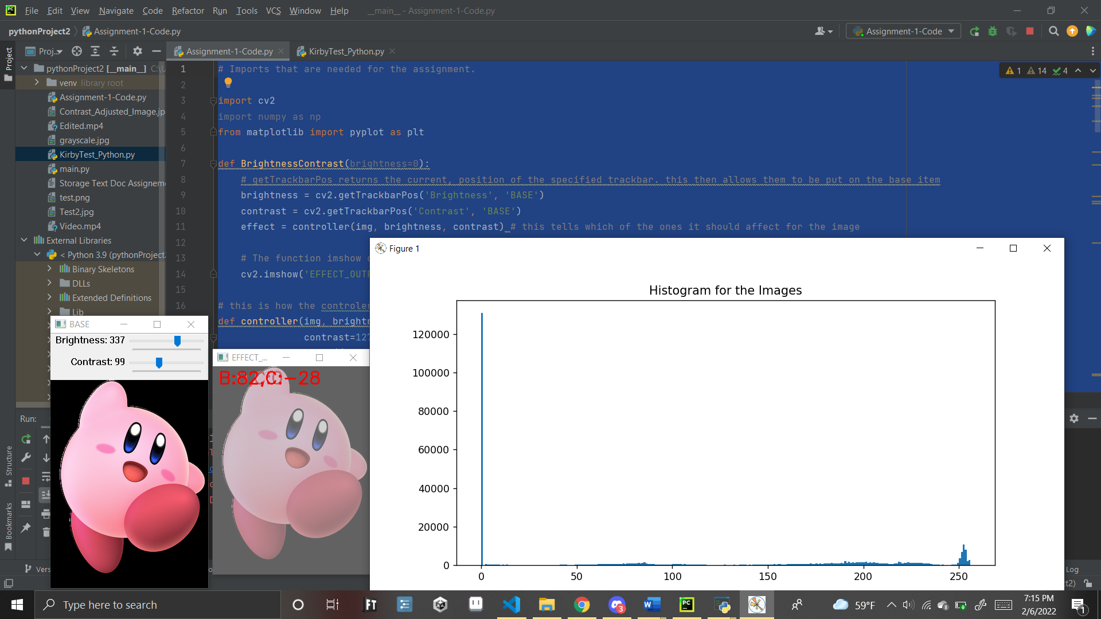
This results in it being used to render images and histograms for those images. Were able to adjust image contrast with the code, and by exiting we save a copy of the contrast and brightness render image shown.

Figure 6 – Code 1: image adjustments and saving with histogram

Then using the other code, we have from, “1.2.1.3 Code that is used for rendering video - Learn OpenCV” we do the double video render as seen here. While we were unable to combine them, we were at least able to make 2 separate versions of these codes that at least covers most of the functionalities despite many, many setbacks.

Figure 7- Code 2: Double video render
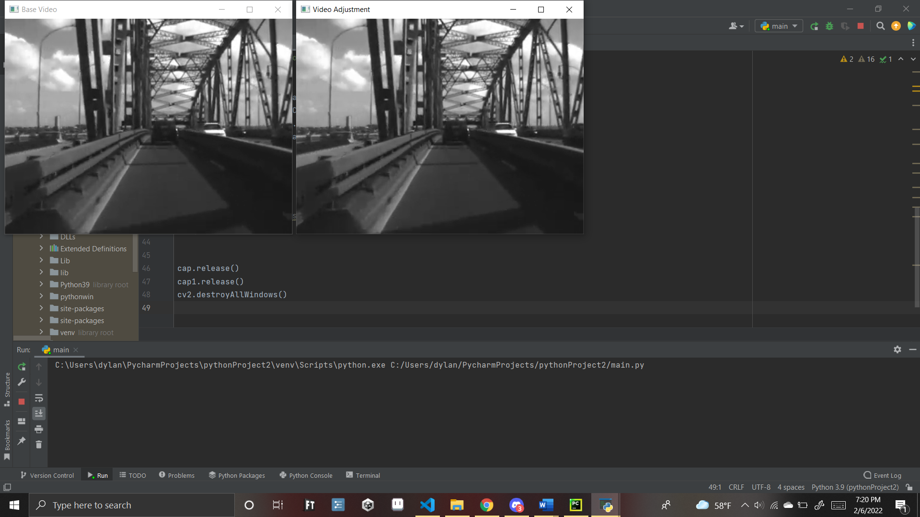

Results and Conclusion
To end, we managed to produce the following items code wise:

- Output that can display two videos at once
- Output that can adjust the contrast and brightness of an image, and display a histogram.
- Ability to save a copy of an image
These results while not the exact requested items for the project, was as close as I could get within the time allotted, and with the help we gotten as we never got any reply back via email. We are sorry we could not produce better results, and will be in also to try and figure out the rest of the code in order to make it work.

Below is the final code we have mainly it been geeks for geeks code as a base in order to be able to do the proper rendering, as we could not find any other code that did this correctly

# Imports that are needed for the assignment.
import cv2
import numpy as np
from matplotlib import pyplot as plt
def BrightnessContrast(brightness=0):
# getTrackbarPos returns the current, position of the specified trackbar. this then allows them to be put on the base item
brightness = cv2.getTrackbarPos('Brightness', 'BASE')
contrast = cv2.getTrackbarPos('Contrast', 'BASE')
effect = controller(img, brightness, contrast) # this tells which of the ones it should affect for the image
# The function imshow displays an image, in the specified window, and then puts out this window
cv2.imshow('EFFECT_OUTPUT', effect)
# this is how the controlers work, first put up the ranges for the brightness and contrast,
def controller(img, brightness=255,
contrast=127):
brightness = int((brightness - 0) * (255 - (-255)) / (510 - 0) + (-255))
contrast = int((contrast - 0) * (127 - (-127)) / (254 - 0) + (-127))
# check if it is not wqual to 0 if it is over 0 make brighter up to max of 255, else make it darker
if brightness != 0:
if brightness > 0:
shadow = brightness
max = 255
else:
shadow = 0
max = 255 + brightness
al_pha = (max - shadow) / 255
ga_mma = shadow
# The function addWeighted calculates
# the weighted sum of two arrays
cal = cv2.addWeighted(img, al_pha,
img, 0, ga_mma)
else:
cal = img
# same thing with contrast just with a different range and also application of different formula in order to raise contrast instead of brightness
if contrast != 0:
Alpha = float(131 * (contrast + 127)) / (127 * (131 - contrast))
Gamma = 127 * (1 - Alpha)
# The function addWeighted calculates
# the weighted sum of two arrays
cal = cv2.addWeighted(cal, Alpha,
cal, 0, Gamma)
# putText renders the specified text string in the image.
cv2.putText(cal, 'B:{},C:{}'.format(brightness,
contrast), (10, 30),
cv2.FONT_HERSHEY_SIMPLEX, 1, (0, 0, 255), 2)
return cal
# this gets the data needed for rendering the images
if __name__ == '__main__':
# The function imread loads an image
# from the specified file and returns it.
original = cv2.imread("test.png")
# Making another copy of an image.
img = original.copy()
# The function namedWindow creates a
# window that can be used as a placeholder
# for images.
cv2.namedWindow('BASE')
# The function imshow displays an
# image in the specified window.
cv2.imshow('BASE', original)
# createTrackbar(trackbarName,
# windowName, value, count, onChange)
# Brightness range -255 to 255
cv2.createTrackbar('Brightness',
'BASE', 255, 2 * 255,
BrightnessContrast)
# Contrast range -127 to 127
cv2.createTrackbar('Contrast', 'BASE',
127, 2 * 127,
BrightnessContrast)
# this is mainly where new code comes into play to get the Histogram for base image
histogram_base = cv2.calcHist(img, [0], None, [256], [0, 256])
plt.hist(img.ravel(), 256, [0, 256])
plt.title('Histogram for the Images')
plt.show()
# should save a copy of the edited image, it sort of works but didnt
cv2.imwrite('Contrast_Adjusted_Image.jpg', img)
BrightnessContrast(0)
# The function waitKey waits for
# a key event infinitely or for delay
# milliseconds, when it is positive.
cv2.waitKey(0)

Figure 8 – Main final code results

A bunch more other rough failed code models appear at the end of this document as well, a lot of them in fact, check the “Failed Code Models” for a slew of more code.

UPDATE: Extension and New Information
So due to a mass number of students having issue with this assignment the time period for it was extended a week. In theory this should allow me to get done more of the assignment. Unfortunately, in practice this did not occur. Mainly, this is due to having to get done work for other classes, such as programing languages, senior design, and machine learning, compounded with also the fact that we are hunting for a job for after graduation and that this took up a bit of our time as well without any real payoffs, this left us very limited windows to work on it.

However, despite such we still did make the attempt to try and implement the various other things listed in the example codes that were given to us, the results were more or less the same as the other one. Mainly we tried using the info at link: https://docs.opencv.org/4.x/dd/d43/tutorial_py_video_display.html in order to save the video, and if we could get this to work, we would also continue further on with the assignment the code listed for this was the following:

import numpy as np
import cv2 as cv
cap = cv.VideoCapture(0)
# Define the codec and create VideoWriter object
fourcc = cv.VideoWriter_fourcc(*'XVID')
out = cv.VideoWriter('output.avi', fourcc, 20.0, (640, 480))
while cap.isOpened():
ret, frame = cap.read()
if not ret:
print("Can't receive frame (stream end?). Exiting ...")
break
frame = cv.flip(frame, 0)
# write the flipped frame
out.write(frame)
cv.imshow('frame', frame)
if cv.waitKey(1) == ord('q'):
break
# Release everything if job is finished
cap.release()
out.release()
cv.destroyAllWindows()

And lead to us coming up with the following modifications to our video code
# import the cv2 library - Displays two videos, still needs histograms proprer saving and adjustment bars implemented correctly
import cv2
# Import this for the histogram
import numpy as np
from matplotlib import pyplot as plt
# Create a VideoCapture object and read from input file
# If the input is the camera, pass 0 instead of the video file name
#cap is the starting default video, Cappy is the edited copy of the vide
Base = cv2.VideoCapture('Video.mp4')
Changed = cv2.VideoCapture('Video.mp4')
# Define the codec and create VideoWriter object
fourcc = cv2.VideoWriter_fourcc(*'XVID')
out = cv2.VideoWriter('output.avi', fourcc, 20.0, (640, 480))
# Check if camera opened successfully
if (Base.isOpened() == False):
print("Error opening video stream or file: Default video ")
if (Changed.isOpened() == False):
print("Error opening video stream or file: Editing Video did not display")
# Read until video is completed
while (Base.isOpened()):
# Capture frame-by-frame
ret, frame = Base.read()
ret1, frame2 = Changed.read()
if ret == True:
# Display the resulting frame of the video
cv2.imshow('Base Video', frame)
cv2.imshow('Video Adjustment', frame2) #Note Frame 2 allows it to be different from frame 1
# loop the video once it reaches the end
if ret == False:
Base = cv2.VideoCapture('Video.mp4')
Changed = cv2.VideoCapture('Video.mp4')
ret, image = Base.read()
ret1, image2 = Changed.read()
# Press Q on keyboard to exit the video program
if cv2.waitKey(25) & 0xFF == ord('q'):
break
if cv2.waitKey(25) & 0xFF == ord('s'):
out.write(frame2)
break
Base.release()
Changed.release()
cv2.destroyAllWindows()

Figure 9: Video Code that Should Save

However, the output that occurred with the video simply does not work and gives the following error, and by this point, I quite frankly do not want to continue this assignment as the mere mention of open cv by name is literally enough now to give me a headache, and that is not a hyperbole. As such we have decided that we will simply turn in what we have for it and allow you to judge from there.

Figure 10: Video Code that Should Save Error Msg

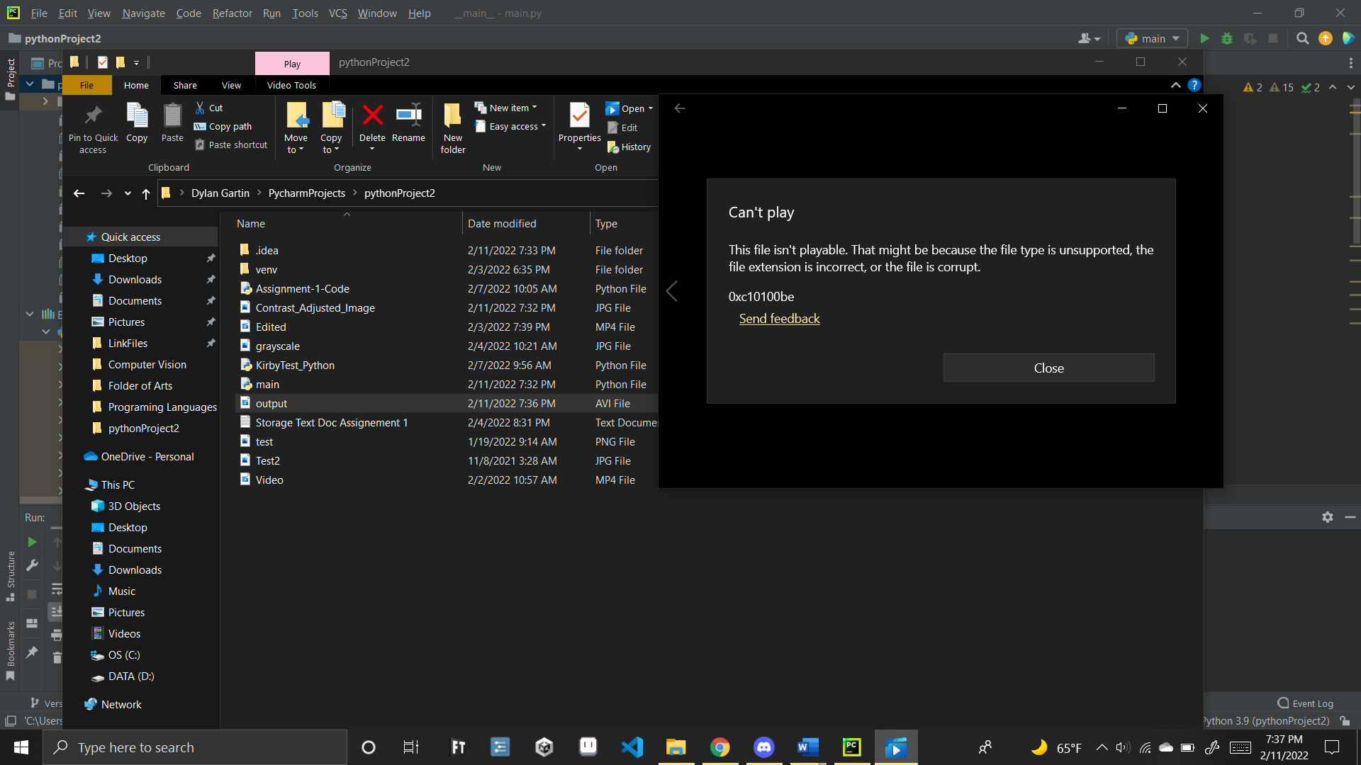
References
The following sources were mainly used:

- “Changing the Contrast and Brightness of an Image Using Python - Opencv.” GeeksforGeeks, 12 Dec. 2021, www.geeksforgeeks.org/changing-the-contrast-and-brightness-of-an-image-using-python-opencv/.
- “Getting Started with Videos.” OpenCV, docs.opencv.org/4.x/dd/d43/tutorial_py_video_display.html.
- “Histograms - 1 : Find, Plot, Analyze !!!” OpenCV, docs.opencv.org/4.x/d1/db7/tutorial_py_histogram_begins.html.
- Saha, Avinab. “Read, Write and Display a Video Using Opencv |.” LearnOpenCV, 5 May 2021, learnopencv.com/read-write-and-display-a-video-using-opencv-cpp-python/.

Additional resources were looked into as well as items provided by the professor which are show below but the above are the main code models
def plot(x):
hist, bins = np.histogram(frame.flatten(),256,[0,256])
cdf = hist.cumsum()
cdf_normalized = cdf * hist.max() / cdf.max()
plt.plot(cdf_normalized, color='b')
plt.hist(frame.flatten(),256,[0,256])
plt.xlim([0,256])
plt.legend(('cdf', 'histogram'), loc = 'upper right')
cv2.setTrackbarPos('Histogram', 'Curve Tool', 0)
fig.cavas.draw()
img = np.frombuffer(fig.canvas.tostring_rgb(),dtype=np.int8)
img = img.reshape(fig.canvas.get_width_height()[::-1] +(3,))
img = cv2.cvtColor(img,cv.COLOR_RGB2BGR)
cv2.imshow('Histogram', img)

Failed code models
The following is many more failed lines of code that for one reason or another did not produce the results that we were wanting and as such were scraped, see the next pages for details about them.

# Create a VideoCapture object and read from input file
# If the input is the camera, pass 0 instead of the video file name
#cap is the starting default video, Cappy is the edited copy of the vide
base_image_file = cv2.VideoCapture('Video.mp4')
edited_image_file = cv2.VideoCapture('Video.mp4')

# Check if camera opened successfully
if (base_image_file.isOpened() == False):
print("Error opening video stream or file: Default video ")

if (edited_image_file.isOpened() == False):
print("Error opening video stream or file: Editing Video did not display")

# Read until video is completed
while (base_image_file.isOpened()):

# Capture frame-by-frame
ret, frame = base_image_file.read()
ret1, frame2 = edited_image_file.read()
if ret == True:

# Display the resulting frame of the video
cv2.imshow('Base Video', frame)
cv2.imshow('Video Adjustment', frame2) #Note Framer is

# loop the video once it reaches the end
if ret == False:
base_image_file = cv2.VideoCapture('Video.mp4')
edited_image_file= cv2.VideoCapture('Video.mp4')
ret, image = base_image_file.read()
ret1, image2 = edited_image_file.read()
#Histogram for base image

# Press Q on keyboard to exit the video program
if cv2.waitKey(25) & 0xFF == ord('q'):
break

if cv2.waitKey(25) & 0xFF == ord('s'):
# save the changes to the video and then exit
ret, frame2 = edited_image_file.read()
result = cv2.VideoWriter('Edited.mp4', cv2.VideoWriter_fourcc(*'MPEG'), 10, size) # needs fixing
result.write(frame2)
cv2.imshow('Video Adjustment', frame2)
break

cv2.destroyAllWindows()

histogram_base = cv2.calcHist(base_image_file, [0], None, [256], [0, 256])
plt.hist(base_image_file.ravel(), 256, [0, 256])

histogram_edited = cv2.calcHist(edited_image_file, [0], None, [256], [0, 256])
plt.hist(edited_image_file.ravel(), 256, [0, 256])
plt.title('Histogram for the Images')
plt.show()

# import the cv2 library - Displays two videos, still needs histograms proprer saving and adjustment bars implemented correctly
import cv2
# Import this for the histogram
import numpy as np
from matplotlib import pyplot as plt
# Create a VideoCapture object and read from input file
# If the input is the camera, pass 0 instead of the video file name
#cap is the starting default video, Cappy is the edited copy of the vide
cap = cv2.VideoCapture('Video.mp4')
cap1 = cv2.VideoCapture('Video.mp4')

# Check if camera opened successfully
if (cap.isOpened() == False):
print("Error opening video stream or file: Default video ")

if (cap1.isOpened() == False):
print("Error opening video stream or file: Editing Video did not display")

# Read until video is completed
while (cap.isOpened()):

# Capture frame-by-frame
ret, frame = cap.read()
ret1, frame2 = cap1.read()
if ret == True:

# Display the resulting frame of the video
cv2.imshow('Base Video', frame)
cv2.imshow('Video Adjustment', frame2) #Note Framer is
# loop the video once it reaches the end
if ret == False:
cap = cv2.VideoCapture('Video.mp4')
cap1 = cv2.VideoCapture('Video.mp4')
ret, image = cap.read()
ret1, image2 = cap1.read()

# Press Q on keyboard to exit the video program
if cv2.waitKey(25) & 0xFF == ord('q'):
break
if cv2.waitKey(25) & 0xFF == ord('s'):
#save the changes to the video and then exit
break

cap.release()
cap1.release()
cv2.destroyAllWindows()

# Code that displays the Histogram does that correctly but stops the video from playing proper- video makes the histogram for 1 frame
histogram = cv2.calcHist([frame2], [0], None, [256], [0, 256])
plt.plot(histogram, color='k')
plt.show(block = false)

# Code set that does save an MP4 - but not properly and has an error that i can not solve.

# import the cv2 library
import cv2
# Import this for the histogram
import numpy as np
from matplotlib import pyplot as plt

# Create a VideoCapture object and read from input file
# If the input is the camera, pass 0 instead of the video file name
#cap is the starting default video, Cappy is the edited copy of the vide
cap = cv2.VideoCapture('Video.mp4')
cap1 = cv2.VideoCapture('Video.mp4')

# get the dimesntions of the edit frame so that way we can put them into the function to save them
frame_width = int(cap1.get(3))
frame_height = int(cap1.get(4))

size = (frame_width, frame_height)

# Check if camera opened successfully
if (cap.isOpened() == False):
print("Error opening video stream or file: Default video ")

if (cap1.isOpened() == False):
print("Error opening video stream or file: Editing Video did not display")

# Read until video is completed
while (cap.isOpened()):

# Capture frame-by-frame
ret, frame = cap.read()
ret1, frame2 = cap1.read()
if ret == True:

# Display the resulting frame of the video
cv2.imshow('Base Video', frame)
cv2.imshow('Video Adjustment', frame2) #Note the different names lets it be different frames

#test to see if makes histogram

# loop the video once it reaches the end
if ret == False:
cap = cv2.VideoCapture('Video.mp4')
cap1 = cv2.VideoCapture('Video.mp4')
ret, image = cap.read()
ret1, image2 = cap1.read()

# Press Q on keyboard to exit the video program
if cv2.waitKey(25) & 0xFF == ord('q'):
break
if cv2.waitKey(25) & 0xFF == ord('s'):
# save the changes to the video and then exit
ret, frame2 = cap1.read()
result = cv2.VideoWriter('Edited.mp4', cv2.VideoWriter_fourcc(*'MPEG'), 10, size) #needs fixing
result.write(frame2)
cv2.imshow('Video Adjustment', frame2)

break

# release the other video items as to not take data
cap.release()
cap1.release()
cv2.destroyAllWindows()

# and then this stuff makes the bars but this only seems to work for images

import cv2

def BrightnessContrast(brightness=0):

# getTrackbarPos returns the current
# position of the specified trackbar.
brightness = cv2.getTrackbarPos('Brightness',
'GEEK')

contrast = cv2.getTrackbarPos('Contrast',
'GEEK')

effect = controller(img, brightness,
contrast)

# The function imshow displays an image
# in the specified window
cv2.imshow('Effect', effect)

def controller(img, brightness=255,
contrast=127):

brightness = int((brightness - 0) * (255 - (-255)) / (510 - 0) + (-255))

contrast = int((contrast - 0) * (127 - (-127)) / (254 - 0) + (-127))

if brightness != 0:

if brightness > 0:

shadow = brightness

max = 255

else:

shadow = 0
max = 255 + brightness

al_pha = (max - shadow) / 255
ga_mma = shadow

# The function addWeighted calculates
# the weighted sum of two arrays
cal = cv2.addWeighted(img, al_pha,
img, 0, ga_mma)

else:
cal = img

if contrast != 0:
Alpha = float(131 * (contrast + 127)) / (127 * (131 - contrast))
Gamma = 127 * (1 - Alpha)

# The function addWeighted calculates
# the weighted sum of two arrays
cal = cv2.addWeighted(cal, Alpha,
cal, 0, Gamma)

# putText renders the specified text string in the image.
cv2.putText(cal, 'B:{},C:{}'.format(brightness,
contrast), (10, 30),
cv2.FONT_HERSHEY_SIMPLEX, 1, (0, 0, 255), 2)

return cal

if __name__ == '__main__':
# The function imread loads an image
# from the specified file and returns it.
original = cv2.imread("pic.jpeg")

# Making another copy of an image.
img = original.copy()

# The function namedWindow creates a
# window that can be used as a placeholder
# for images.
cv2.namedWindow('GEEK')

# The function imshow displays an
# image in the specified window.
cv2.imshow('GEEK', original)

# createTrackbar(trackbarName,
# windowName, value, count, onChange)
# Brightness range -255 to 255
cv2.createTrackbar('Brightness',
'GEEK', 255, 2 * 255,
BrightnessContrast)

# Contrast range -127 to 127
cv2.createTrackbar('Contrast', 'GEEK',
127, 2 * 127,
BrightnessContrast)

BrightnessContrast(0)

# The function waitKey waits for
# a key event infinitely or for delay
# milliseconds, when it is positive.
cv2.waitKey(0)

BACKUP

# import the cv2 library
import cv2
# Import this for the histogram
import numpy as np
from matplotlib import pyplot as plt

# Create a VideoCapture object and read from input file
# If the input is the camera, pass 0 instead of the video file name
#cap is the starting default video, Cappy is the edited copy of the vide
cap = cv2.VideoCapture('Video.mp4')
cap1 = cv2.VideoCapture('Video.mp4')

# get the dimesntions of the edit frame so that way we can put them into the function to save them
frame_width = int(cap1.get(3))
frame_height = int(cap1.get(4))

size = (frame_width, frame_height)

# Check if camera opened successfully
if (cap.isOpened() == False):
print("Error opening video stream or file: Default Video did not display")

if (cap1.isOpened() == False):
print("Error opening video stream or file: Editing Video did not display")

# Read until video is completed
while (cap.isOpened()):

# Capture frame-by-frame
ret, frame = cap.read()
ret1, frame2 = cap1.read()
#test to see if makes histogram
histogram = cv2.calcHist([frame2], [0], None, [256], [0, 256])
plt.plot(histogram, color='k')
plt.show(block = False)

if ret == True:

# Display the resulting frame of the video
cv2.imshow('Base Video', frame)
cv2.imshow('Video Adjustment', frame2) #Note the different names lets it be different frames

# loop the video once it reaches the end
if ret == False:
cap = cv2.VideoCapture('Video.mp4')
cap1 = cv2.VideoCapture('Video.mp4')
ret, image = cap.read()
ret1, image2 = cap1.read()

# Press Q on keyboard to exit the video program
if cv2.waitKey(25) & 0xFF == ord('q'):
break
if cv2.waitKey(25) & 0xFF == ord('s'):
# save the changes to the video and then exit
ret, frame2 = cap1.read()
result = cv2.VideoWriter('Edited.mp4', cv2.VideoWriter_fourcc(*'MPEG'), 10, size) #needs fixing
result.write(frame2)
cv2.imshow('Video Adjustment', frame2)
break

# release the other video items as to not take data
cap.release()
cap1.release()
cv2.destroyAllWindows()

# import the cv2 library - Displays two videos, still needs histograms proprer saving and adjustment bars implemented correctly
import cv2
# Import this for the histogram
import numpy as np
from matplotlib import pyplot as plt
# Create a VideoCapture object and read from input file
# If the input is the camera, pass 0 instead of the video file name
#cap is the starting default video, Cappy is the edited copy of the vide
cap = cv2.VideoCapture('Video.mp4')
cap1 = cv2.VideoCapture('Video.mp4')

# Check if camera opened successfully
if (cap.isOpened() == False):
print("Error opening video stream or file: Default video ")

if (cap1.isOpened() == False):
print("Error opening video stream or file: Editing Video did not display")

# Read until video is completed
while (cap.isOpened()):

# Capture frame-by-frame
ret, frame = cap.read()
ret1, frame2 = cap1.read()
if ret == True:

# Display the resulting frame of the video
cv2.imshow('Base Video', frame)
cv2.imshow('Video Adjustment', frame2) #Note Framer is

# Code that displays the Histogram does that correctly but stops the video from playing proper- video makes the histogram for 1 frame
histogram = cv2.calcHist([frame2], [0], None, [256], [0, 256])
plt.plot(histogram, color='k')
fig.canvas

# loop the video once it reaches the end
if ret == False:
cap = cv2.VideoCapture('Video.mp4')
cap1 = cv2.VideoCapture('Video.mp4')
ret, image = cap.read()
ret1, image2 = cap1.read()

# Press Q on keyboard to exit the video program
if cv2.waitKey(25) & 0xFF == ord('q'):
break
if cv2.waitKey(25) & 0xFF == ord('s'):
#save the changes to the video and then exit
break

cap.release()
cap1.release()
cv2.destroyAllWindows()

